马来西亚思特雅大学（UCSI）工商管理硕士（MBA）

马来西亚唯一一所世界排名前500的私立大学
马来西亚第一所被教育部批准开设医学类课程的私立(独立）大学
中国教育部第一批承认学位学历的马来西亚的大学
全马唯一一所提供多元化课程的综合性私立（独立）大学

马来西亚思特雅大学（UCSI）简介
UCSI大学成立于1986年，为马来西亚顶尖的高等学府之一，分别在吉隆坡、丁加奴和古晋设有分校，以 “无畏、坚毅、诚信和精进” 为办学原则。据最新的QS世界大学排名，思特雅大学全球排名481，马来西亚第四（前三所大学均为马来西亚公立大学），是中国教育部公布承认的海外大学之一，其资质可登陆中国教育部涉外监管信息网查询（www.jsj.edu.cn）。思特雅大学（UCSI）是马来西亚一流的国际大学，有着“花园校园”的美称。她坐落于马来西亚首都吉隆坡市的心脏地区康乐花园，处交通便利、商业繁华的黄金地段，有校车往返于南北校区、学生宿舍及教学楼之间。校园内有大型综合楼、咨询楼、 学术楼和学生公寓，以及篮球场、羽毛球场、排球场、体育场、大型会议室、音乐教学设备、语音室、图书馆、学生活动中心、工程实验室、药剂实验室、电脑实验室及应用科学实验室等大型文化体育和教学实验场所，校园外并配备有多达一千张病床的UCSI大学附属医院。总校在校学生12000多人，其中中国学生近600多人，其它学生来自全球60多个国家和地区，是一所名副其实的国际大学。
UCSI大学坚持卓越、独特、自由的办学模式，正朝世界最优秀的大学迅速迈进——UCSI大学商业与资讯科学学院（FoBIS）是在UCSI大学生报读人数最大的学院之一。培养出的学生均为企业领导或社会精英，遍及世界各大跨国公司。UCSI商业与资讯科学院（FoBIS）拥有世界最高水准的学术水平，可向学员提供不断创新的高阶课程，拥有非常高的国际声誉。

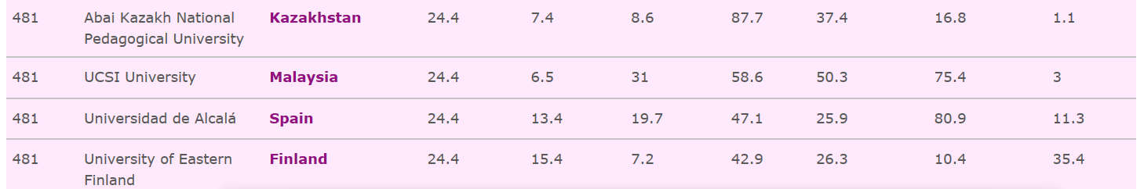

项目优势：
名校联合：国内著名高校（985和211大学）和UCSI大学（世界500强大学）联合培养；
无需联考：不需参加全国联考，轻松获得工商管理硕士学位；
权威认证：可获得中国教育部中国留学服务中心认证，享受留学生待遇；证书可用于公司上市、加薪晋升、评职称、移民加分、学历提升等
在职学习：周末上课和线上学习相结合，工作学习两不误；
高通过率：每门课程提交作业，修完规定学分，完成论文及答辩，即可获得相应学位证书
入学资格
国内外认可的本科学历
学籍管理：
所有学生均在马来西亚教育部和思特雅大学进行学籍注册，并接受马来西亚教育部和思特雅大学管理。

课程设置：
核心课程
商业政策与战略管理 | 蓝海策略 | 商法中热点问题
财务会计及分析 | 财务管理与政策 | 管理者信息技术
国际商务与管理 | 人力资源管理与组织行为学 | 营销管理
商业与管理研究方法 | 硕士课程项目 | 硕士课程项目规划
选修课程
业务营运及物流管理 | 管理会计学与决策 | 管理经济学
零售及服务市场 | 电子商务策略 | 供应链管理
备注：选修课程并非全部开设，根据学院人数及开课情况临时调整。

授课形式：
中马名校联合培养，国内外校区分别授课。国内校区授课四门，国外校区和线上授课八门，具体课程另行通知。根据教育主管部门规定的每学期全日制在校学习上课的时间标准，国外校区在教育主管部门规定标准学期上课时段内授课每年5次（每个大学期2次以上，每个小学期1次以上），每次全日制连续授课半个月以上。

考试考核：
UCSI-MBA课程缴交作业与论文,每一科目的个人专题作业（或小组专题作业或学习报告）（3000个字以上）。硕士论文则需至少三万五千字以上。论文答辩由UCSI派教授主持。

毕业及学位证书：
顺利完成本课程并通过答辩的毕业生，将由思特雅大学UCSI颁发马来西亚国家学历管理局正式承认的正规工商管理硕士（MBA）学位证书（含学历，在英联邦国家系统，学位证书与毕业证书合二为一）, 可继续申请攻读工商管理博士学位，毕业生可在其姓名之后使用思大学衔：MBA（UCSI）。毕业典礼定于每年7月在 UCSI 大学总校举行。

收费标准：
1、国内四个月面授，八个月线上课程，学费：158000元/人
2、国内四个月面授，国外集中5次，每次两周，学费：198000元/人

其他费用说明
1、留学签证申请费：约RMB 3000元整
2、书杂费：约RMB 1200元整
3、其它食宿交通等费用另计。

HEALTH EXAMINATION GUIDELINES

FOR ENTRY INTO

MALAYSIAN HIGHER EDUCATIONAL INSTITUTIONS

- PLEASE READ THE INSTRUCTIONS CAREFULLY BEFORE FILLING IN THE FORM.

- PLEASE FILL IN THE FORM IN ENGLISH LANGUAGE.

- PLEASE WRITE IN CAPITAL LETTERS.

- THIS FORM HAS 4 SECTIONS:

  - SECTION 1 (PART A AND B) TO BE FILLED BY THE APPLICANT; AND

  - SECTION 2,3 AND 4 TO BE FILLED BY THE EXAMINING DOCTOR

- PLEASE COMPLETE THE ENTIRE TEST REQUIRED IN THIS FORM.

- THE UNIVERSITY / COLLEGE ONLY ACCEPT MEDICAL EXAMINATION DONE WITHIN

90 DAYS BEFORE ARRIVAL IN MALAYSIA.

- PLEASE ATTACH ALL THE ORIGINAL LABORATORY RESULTS.

- PLEASE BRING ALONG CHEST X-RAY FILM (OR DIGITAL IMAGES) AND REPORT

FOR REGISTRATION, FOR THE PURPOSE OF VERIFICATION, IF NECESSARY.

- PLEASE ENSURE THE X-RAY FILMS OR DIGITAL IMAGES ARE LABELLED WITH

YOUR NAME AND DATE TAKEN (IN ENGLISH).

- CHEST X-RAY DONE WITHIN 6 MONTHS PRIOR TO REGISTRATION CAN BE

ACCEPTED.

- THE UNIVERSITY / COLLEGE RESERVES THE RIGHT TO REPEAT FULL MEDICAL

CHECK UP OR ANY SPECIFIC LABORATORY TESTS SHOULD THERE BE ANY

DOUBT IN THE MEDICAL REPORT SUBMITTED, ALL COSTS INVOLVED SHALL BE

BORNE BY THE CANDIDATES.

- THE UNIVERSITY / COLLEGE RESERVES THE RIGHT TO REJECT ANY

APPLICATION:

  - BASED ON THE RESULTS OF THE HEALTH EXAMINATION; OR

  - SHOULD THERE BE ANY EVIDENCE THAT THE APPLICANT HAS GIVEN

FALSE INFORMATION IN THE HEALTH EXAMINATION REPORT OR ANY

SUPPORTING DOCUMENTS.

E D U C A T I O N M A L A Y S I A G L O B A L S E R V I C E S ȍ 9 8 6 6 1 0 ǧ U Ȏ

HEALTH EXAMINATION REPORT FOR INTERNATIONAL STUDENTS

SECTION 1 (PART A)

FULL NAME (AS IN PASSPORT)

INTERNATIONAL PASSPORT NUMBER

NATIONALITY

DATE OF BIRTH AGE

ACADEMIC YEAR

PROGRAMME OF STUDY

PROGRAMME CODE

NEXT OF KIN

NEXT OF KIN’S ADDRESS

BLOOD GROUP (RHESUS)

CONTACT NUMBER IN MALAYSIA

SEX MARITAL STATUS

STUDENT ID

NEXT OF KIN’S CONTACT NUMBER

The details of the blood type recorded here are as reported by the patient and have not been tested or verified to be correct by the medical practitioner completing this online medical screening questionnaire. The medical practitioner completing this form disclaims any and all liability to the fullest extent permitted by law for any personal injury, suffering or loss caused by any reliance on this information by any other party.

E D U C A T I O N M A L A Y S I A G L O B A L S E R V I C E S ȍ 9 8 6 6 1 0 ǧ U Ȏ

HEALTH EXAMINATION REPORT FOR INTERNATIONAL STUDENTS

SECTION 1 (PART B)

Declaration of self and family illness. Explain in full if you or your immediate* family has any of the following illnesses. * Immediate family refers to mother, brothers / sisters.

SELF | IMMEDIATE
 | FAMILY |  | If “Yes” please state details
MEDICAL PROBLEMS
Yes No | Yes | No
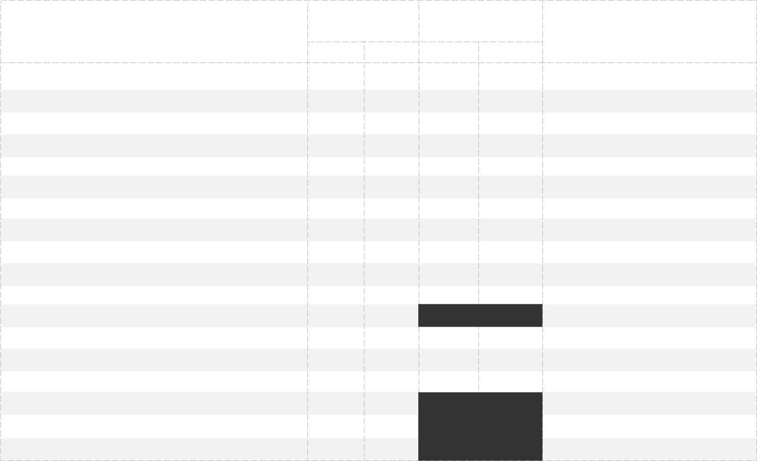
- Congenital or Inherited Disorder

- Allergy

- Mental Illness

- Fits, Stroke, Other Neurological Disease

- Diabetes Mellitus

- Hypertension

- Heart or Vascular Disease

- Asthma

- Thyroid Disease

- Kidney Disease

- Cancer

12. History of Surgery

- Tuberculosis (TB)

- HIV / AIDS

- Hepatitis B

- Sexually Transmitted Diseases

- Drug Addiction

- Other Illnesses

Current medication (Long Term)

VACCINATION HISTORY | Yes | No | Date of Vaccination
(where applicable)
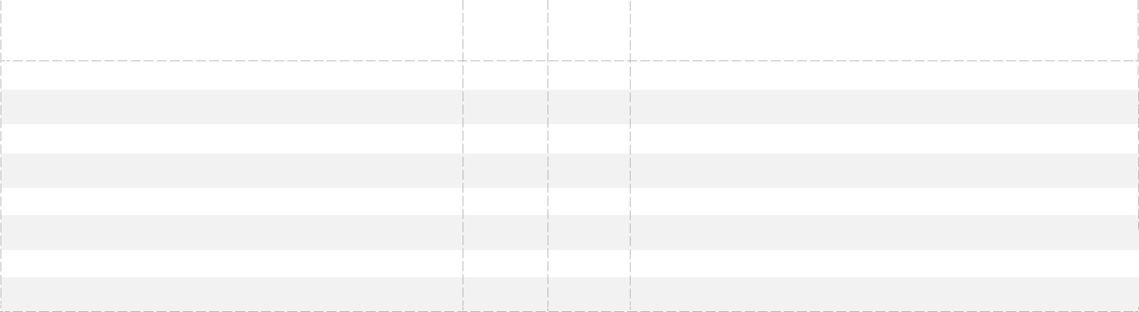
- Yellow Fever

- BCG

- Meningitis (Quadrivalent)

- Hepatitis B

- Polio

- Measles

- Rubella

- Others: (specify)

Notes :

- *A valid Yellow Fever vaccination certificate is required from all travellers coming from or transited more than 12 hours through countries with risk of Yellow Fever transmission.
- All students are required to take vaccines as listed in numbers 2-7 above.

- The students are required to bring along the International Certificate of Vaccination or Prophylaxis with them for verification of information.

E D U C A T I O N M A L A Y S I A G L O B A L S E R V I C E S ȍ 9 8 6 6 1 0 ǧ U Ȏ

HEALTH EXAMINATION REPORT FOR INTERNATIONAL STUDENTS

SECTION 2 - PHYSICAL EXAMINATION

FULL NAME (AS IN PASSPORT)

 | INTERNATIONAL PASSPORT NUMBER |  |  |  |  |  |  |  | TYPE OF APPLICATION
 | DATE OF MEDICAL SCREENING |  |  |  |  |  |  |  | EMGS REFERENCE NUMBER
 | 1. BASIC MEASUREMENT
 | HEIGHT (m) : |  |  | WEIGHT (kg) |  | BMI(kg/m²) |  |  |  |  |  | BLOOD PRESSURE:
 |  |  |  |  |  |  |  |  | PULSE RATE
 |  |  |  |  |  |  |  |  | _{(PER MINUTE)} SYSTOLIC (mmHg) DIASTOLIC (mmHg)
 | VISION TEST |  |  | NORMAL |  | DEFECTIVE
 | UNAIDED (L) |  |  |  |  |  |  |  | COLOR VISION TEST
 | UNAIDED (R) |  |  |  |  |  |  |  | COMMENT
 | AIDED (L)
 | AIDED (R)
 | HEARING ABILITY |  |  | NORMAL |  | DEFECTIVE |  |  | COMMENT
 | LEFT
 | RIGHT

2. GENERAL EXAMINATION

ITEM

- DEFORMITIES

- PALLOR

- CYANOSIS

- JAUNDICE

- OEDEMA

f . SKIN DISEASES

3. SYSTEMIC EXAMINATION

ITEM

  - EYES (including funduscopy)

  - EARS

  - NOSE

  - ORAL CAVITY / THROAT

  - NECK

- CARDIOVASCULAR SYSTEM

- RESPIRATORY SYSTEM

- ABDOMEN/HERNIAL ORIFICES

- NERVOUS SYSTEM

- MENTAL STATUS

- MUSCULOSKELETAL SYSTEM

YES / ABNORMAL NO / NORMAL COMMENT
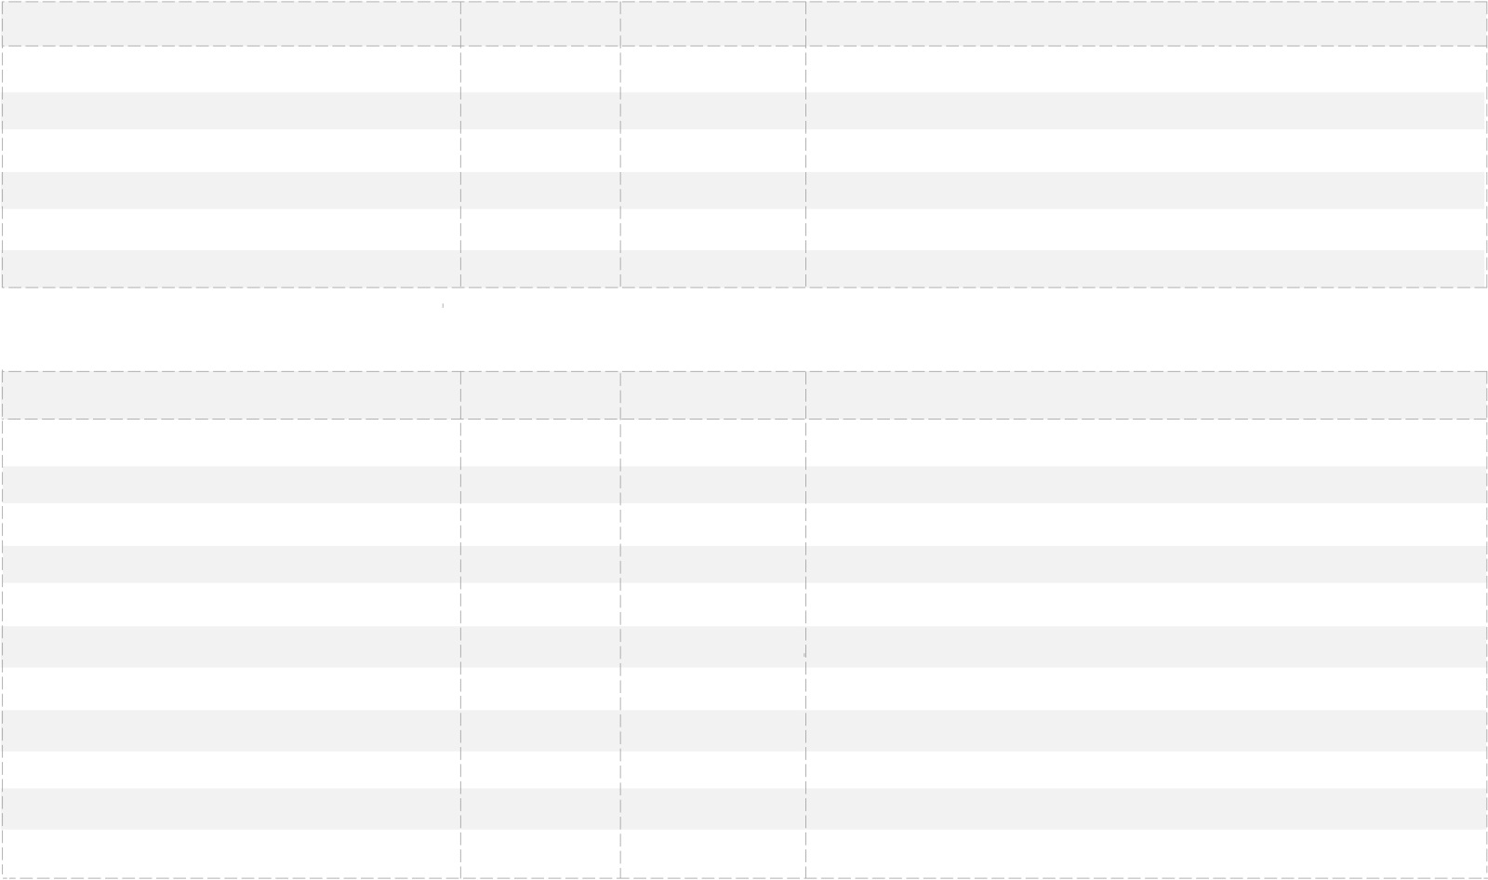

NORMAL ABNORMAL COMMENT

E D U C A T I O N M A L A Y S I A G L O B A L S E R V I C E S ȍ 9 8 6 6 1 0 ǧ U Ȏ

HEALTH EXAMINATION REPORT FOR INTERNATIONAL STUDENTS

SECTION 3 - LABORATORY RESULTS

FULL NAME (AS IN PASSPORT)

 | INTERNATIONAL PASSPORT NUMBER |  | EMGS REFERENCE NUMBER
DATE OF LAB TEST |  |  | NAME OF LAB
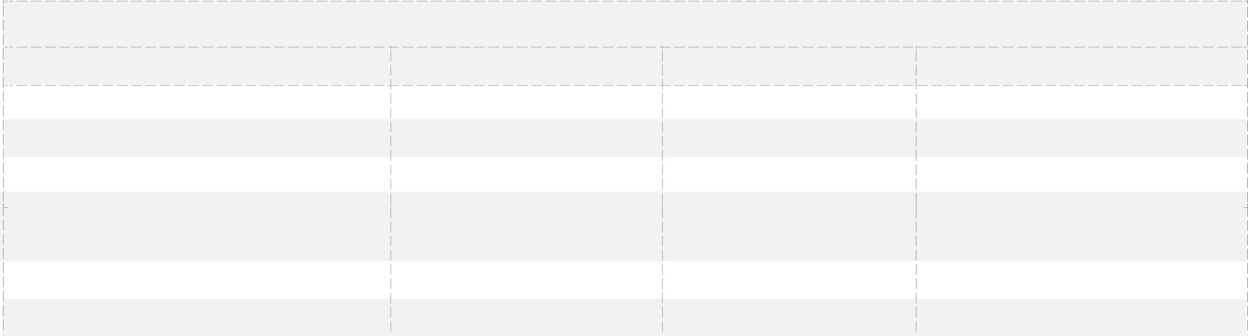

URINE TEST

ITEM POSITIVE / ABNORMAL NEGATIVE / NORMAL COMMENT

- ALBUMIN

- SUGAR

- MICROSCOPIC EXAMINATION

- OPIATES (INCLUDING CODEINE,

MORPHINE, HEROIN)

- CANNABINOIDS

- AMPHETAMINE TYPE STIMULANT
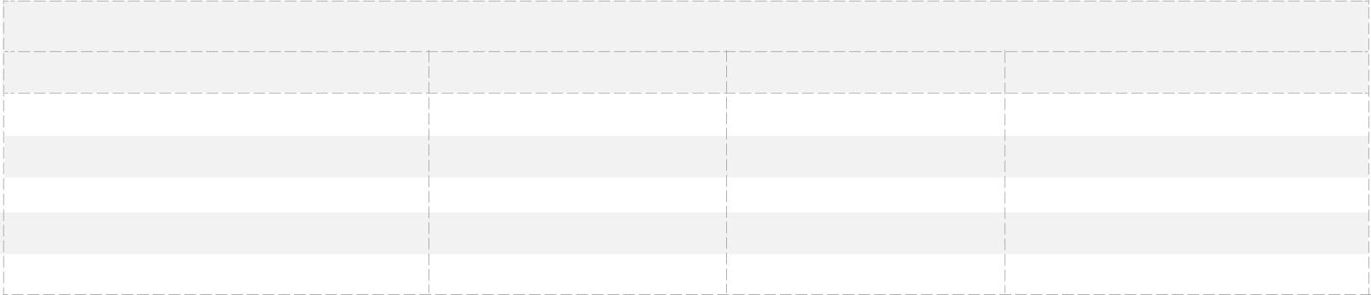

BLOOD TEST

ITEM POSITIVE / ABNORMAL NEGATIVE / NORMAL COMMENT

a. HEPATITIS Bs ANTIGEN

  - HIV

  - VDRL

  - TPHA

  - MALARIAL PARASITES

- TPHA is done if VDRL is reactive

- all test results / reports is valid for 6 months

E D U C A T I O N M A L A Y S I A G L O B A L S E R V I C E S ȍ 9 8 6 6 1 0 ǧ U Ȏ

