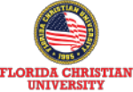

**佛罗里达克里斯汀大学**

佛罗⾥达克⾥斯汀⼤学(FCU)

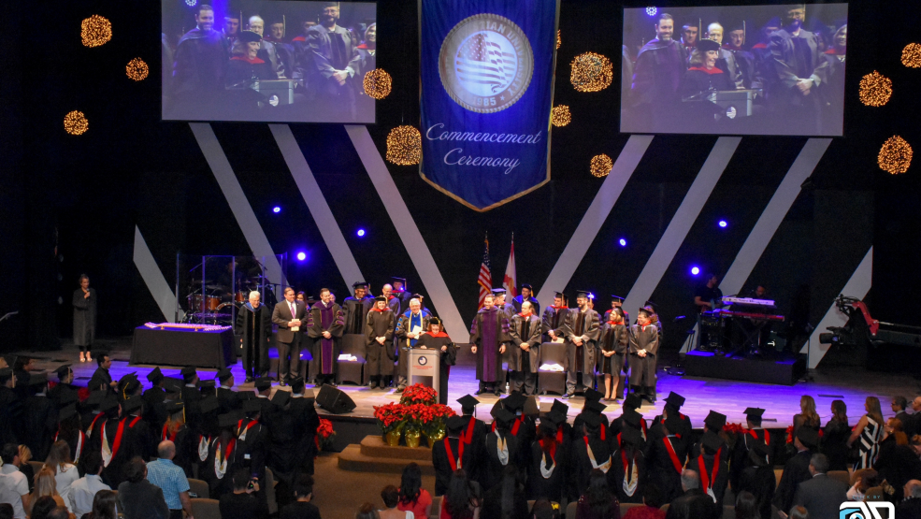Florida Christian University

**商业管理理学硕 士 （ MSC ）**



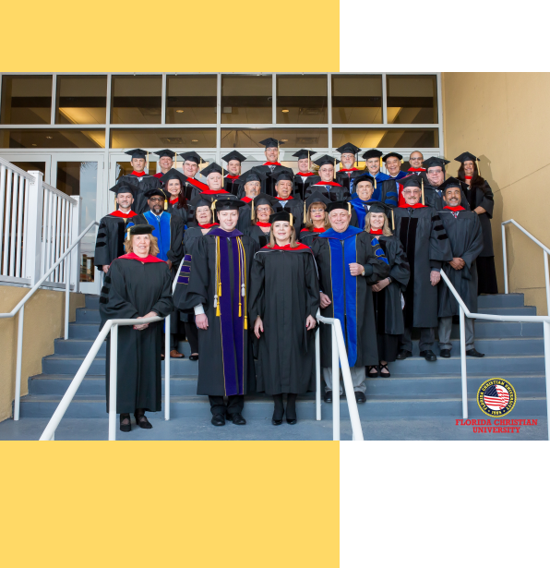

**History**

**学校简介 / University Profile**

佛罗里达克里斯汀大学（Florida Christian University ，简称FCU）创立 于1985年， 是位于佛罗里达州奥兰多市中心的一所综合性私立大学。地

理位置优越，紧邻奥兰多环球影城与奥兰多迪士尼主题乐园。

Florida Christian University (FCU), founded in 1985, is a comprehensive private university located in the heart of Orlando, Florida. It boasts a prime location in close proximity to the

renowned Universal Studios and Walt Disney World theme parks.





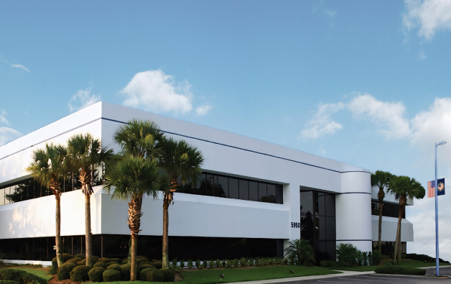

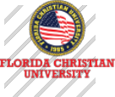

**History**

**学校简介 / University Profile**

佛罗里达克里斯汀大学（FCU）提供超过30种以上的大学与研究所专业，包

括商业、工程、传播、教育、艺术、人类学、社会科学、健康、护理等。

FCU长久以来在学科的教学与研究方面都有卓越的声誉，是符合ABHE以及

许多美国教育部认可的认证机构认可的大学。

Florida Christian University (FCU) offers over 30 diverse undergraduate and graduate programs, spanning various disciplines such as business, engineering,

communication, education, arts, anthropology, social sciences, health, and nursing. FCU has a longstanding reputation for excellence in teaching and

research across these fields and is accredited by ABHE (Association for Biblical Higher Education) and numerous other recognized accreditation agencies by

the U.S. Department of Education.

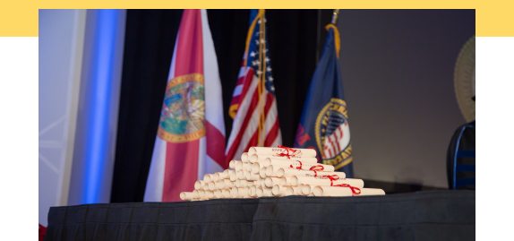

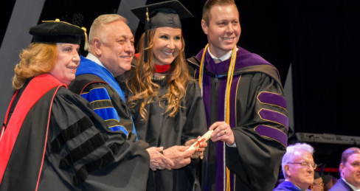

**使命/Mission**

通过实⽤、可变⾰性的⾼等教育，赋予学⽣国际性的视野和⽣存技能。

Empowering students with a practical, transformative higher

education that cultivates an international perspective and essential

life skills.

**愿景/Version**

培养⼀个全球变⾰推动者社区，这些变⾰推动者以基于卓越和正直

履⾏他们的使命。

Cultivating a global community of change agents, individuals who

uphold their missions based on excellence and integrity.

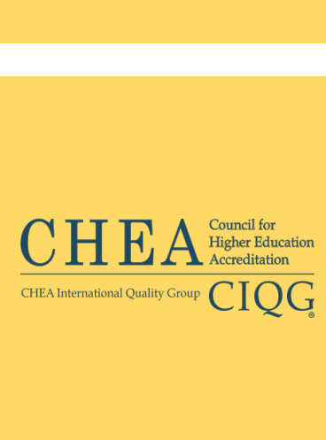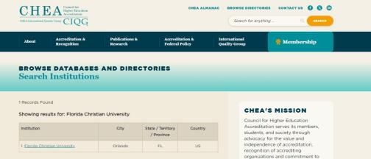

学 校 认 证 **/** L I C E N S U R E

高等教育认证委员会 （英语： Council for Higher Education Accreditation；简写： CHEA）是美国授予学院 和大学学位的组织 。成立目的是提倡通过认证而提供国家对学术品质自我监管，以证实高等教育认证机构 （包括地区、信仰、私人、职业和计划认证机构）的质量。该组织约有3000多个学术机构成员， 目前承认 大约60个认证机构。 高等教育认证委员会总部设在华盛顿特区，是高等教育品质保证国际网络的成员。

The Council for Higher Education Accreditation (CHEA) is a United States organization of degree-granting

colleges and universities. It identifies its purpose as providing national advocacy for academic quality

through accreditation in order to certify the quality of higher education accrediting organizations, including

regional, faith-based, private, career, and programmatic accrediting organizations.The organization has

accredited colleges and universities as members, and currently recognizes approximately 64 accrediting

organizations. CHEA is based in Washington, D.C. CHEA is a member of International Network for Quality

Assurance Agencies in Higher Education (INQAAHE).

CHEA查询官网： <https://www.chea.org/>

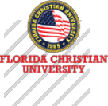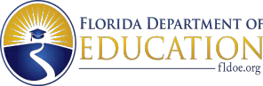

学 校 认 证 **/** L I C E N S U R E

独⽴教育委员会是佛罗⾥达州教育部的⼀个机构，对与⾮公⽴⾼等教育机构有关的事务负有法定责任。佛罗

⾥达克⾥斯汀⼤学获得佛罗⾥达州教育部独⽴教育委员会的许可，许可证号为 6361。

The Independent Education Commission is an entity within the Florida Department of Education responsible

<https://www.fldoe.org/>

for statutory oversight of matters pertaining to non-public higher education institutions. Florida Christian

University has obtained licensure from the Independent Education Commission of the Florida Department of

Education, with License Number 6361.

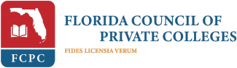

佛罗里达私立学院理事会 (FCPC) 的授予学位的高级会员



美国私立学院理事会 (CPCA) 的授予学位的高级会员

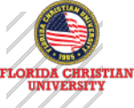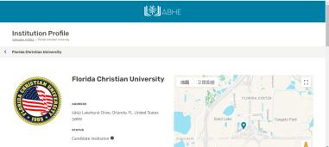

**Accreditation**

ABHE 认证委员会自 1947 年成立，是历史最悠久、经验更丰富的认证机构之一。自美国教育部 1952 年开始认可认证机构以来， ABHE 一直被 美国教育部认可为机构认证机构。

2024 年 2 月 13 日，佛罗里达克里斯汀大学获得圣经高等教育委员会认证协会的候选资格。候选资格是一种预认证资格，授予那些符合 ABHE 资格条件并具备可为五年内获得认证资格奠定基础的机构。候选院校得到美国教育部（ USDE）、高等教育认证委员会（ CHEA）、美国司法部 、美国退伍军人事务部以及美国其他相关联邦机构的认可。

ABHE Commission on Accreditation has been in existence since 1947, making it one of the older and more experienced accrediting bodies. ABHE has maintained recognition by the U.S. Department of Education as an institutional accrediting agency since the

Department began recognizing accrediting agencies in 1952

On February 13, 2024, Florida Christian University was approved for Candidate Status with the Association for Biblical Higher

Education Commission on Accreditation. Candidate status is a Pre-Accreditation status granted to those institutions that meet the ABHE Conditions of Eligibility and that possess such qualities as may provide a basis for achieving accreditation status within five years.Candidate institutions are recognized by the United States Department of Education (USDE), Council for Higher Education

Accreditation (CHEA), the US Department of Justice, the US Department of Veteran Affairs, and other relevant federal agencies in the United States.

ABHE查询官网： <https://www.abhe.org/>

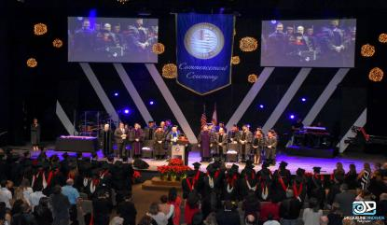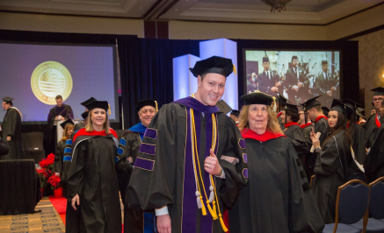项 目 介 绍 **/** Project Introduction

商 业 管理理 学硕 士 （**MSC**）

佛罗里达克里斯汀大学MSC商业管理理学硕士项目，它旨在为学生们提供一系列商业管理的知识、技能和工具，使学生在日益复杂和多变的商 业环境中能够自信地迎接挑战，取得职业上的巨大成功。 MSC课程，覆盖了商业管理的各个方面，从市场营销、财务管理到领导力培养，再到战 略规划，全方面提升学生的专业素养和综合能力。同时，还注重培养学生的创新思维和批判性思考能力，让学生在面对问题时能迅速找到解决方案

,并在实践中不断优化和创新。

The Master of Science in Business Management Program at Florida Christian University is designed to provide students with a range of business management

knowledge, skills and tools that will enable students to confidently meet the challenges and achieve great career success in an increasingly complex and changing business environment. The MSC program covers all aspects of business management, from marketing and financial management to leadership development and

strategic planning, to enhance students' professional quality and comprehensive ability. At the same time, it also focuses on cultivating students' innovative thinking and critical thinking ability, so that students can quickly find solutions when facing problems, and constantly optimize and innovate in practice.

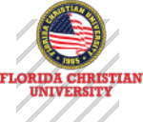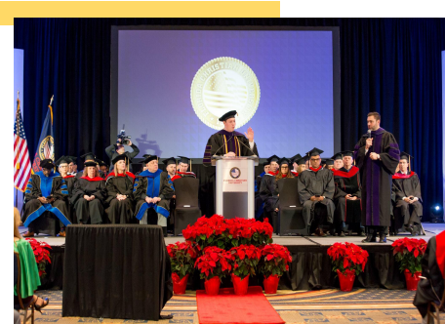

项 目 介 绍 **/** Project Introduction

课程通过模拟实战、小组讨论和案例分析等方式，锻炼学生的思维能力和决策能力，使学生在 学习过程中不断积累经验，为未来的职业发展奠定坚实的基础。

佛罗里达克里斯汀大学MSC商业管理理学硕士项目不仅是一个学术课程，更是一个助力学生职 业发展的强大引擎。它将为学生们提供丰富的知识、技能和经验，帮助他们在商业世界中脱颖而出 , 实现自己的职业梦想。

The course exercises students' thinking and decision-making abilities through simulated actual combat, group discussions, and case analysis, allowing students to continuously accumulate

experience during the learning process and lay a solid foundation for future career development. Florida Christian University's MSC Master of Science in Business Administration program is not

only an academic course, but also a powerful engine that helps students develop their careers. It will provide students with a wealth of knowledge, skills and experience to help them excel in the business world and realize their career dreams.



项 目 优 势 **/** Advantages of the project

**卓越的教育整合能力**

Outstanding Educational Integration Proficiency

整合了批判性思维与创造性思维、综合领导⼒，致⼒于为学⽣提供全⾯的教育⽅法

Integrating critical thinking and creative thinking alongside comprehensive leadership, we are committed to delivering a holistic educational approach to students.

**卓越的教育经验** Exemplary educational experience

促进学生在国际市场的成长和培养领导力发展，

Facilitating students' growth in the international market and fostering leadership development.

**完善的国际教育系统** A well-developed international education system

丰富学⽣经验并培养全球世界观， 500 多个国际⽂凭区域的学者和专业⼈⼠

Enriching student experiences and cultivating a global worldview through a network of scholars and professionals across over 500 international diploma regions.

项 目 优 势 **/** Advantages of the project

**灵活多样的授课方式** Flexible and diverse teaching methods

我们提供各种形式的灵活学习方式，从100%线上授课到线下在校授课、或两者相结合 的灵活教学形式。

We offer a variety of flexible learning options, ranging from 100% online instruction to on- campus in-person classes, or a combination of both in a flexible teaching format.

**多种语言教学** Instruction in multiple languages.

我们为学生提供用语言学习的机会，可选择英语、中文、葡萄牙语和西班牙语的课程。 We provide students with opportunities for language learning, offering courses in

English, Chinese, Portuguese, and Spanish.

**学位证书认证** Degree certificate certification.

学位证书可以获取海牙与WES等权威认证 ，确保学术信誉无忧。

We provide students with opportunities for language learning, offering courses in English, Chinese, Portuguese, and Spanish.

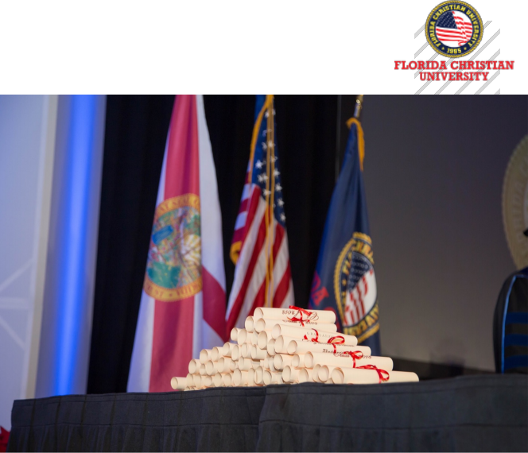

**WHAT MAKES US DIFFERENT**

课 程 设 置 **/** Curriculum



|  |  |
| --- | --- |
| **核心课程**  u 市场研究  Market Research  u 神经营销  Neuromarketing  u 神经经济学  Neuroeconomics  u 神经销售  Neurosales  u 神经商务  Neurobusiness | **/ ASSOCIATE**  u 绩效评估  Performance Assessment  u 科学研究：理论/项目  Scientific Research: Theory&Projec  u 论文：研究/写作  Thesis: Research&Writing  u 论文：答辩  Thesis Defense |

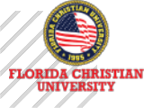



**辅修课／Minor courses**

u 项目管理

Project Management

u 组织战略规划

u 宏观经济学

Macroeconomics

u 选修课3门

Elective courses

Organizational Strategic Planning

u 合作经济与创新

Collaborative Economy and Innovation

u 高绩效团队建设

High-Performance Team Building



入 学 须 知 **/** Admission requirements

**入读条件／Admission conditions**

u 获得管理或相关领域的本科学历；

u 具有本科同等学历学位，并有两年以上工作经验。

（*未具上述学历的申请人，请提供一份管理或相关的成就描述，并向项目办公室提交补充附加材料进行特殊申请。）

**入读材料／Admission conditions**

u 入读申请表

u 个人履历表

u 个人陈述(入学动机信)

u 身份证正反面扫描件、护照首页扫描件

u 本科毕业证或学位证扫描件

u 本科成绩单扫描件

u 2寸白底证件电子照片

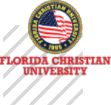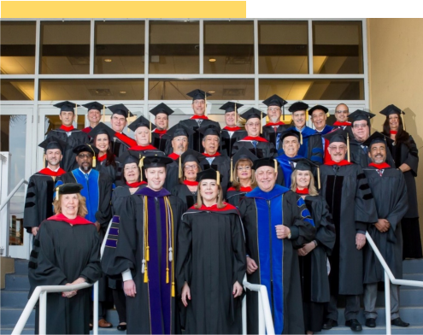

入 学 须 知 **/** Admission requirements

**修读方式／Study Method**

u **类型：**线上美方课 +线下中方面授课

u **学制：** 15个月（具体以实际情况为准）

u **授课安排：**每个月的一个周末，每次两天

u **授课语言：** 中文、英文授课，配有现场翻译

u **教学方式：**教授讲授、案例分析、小组讨论、与行家研讨等，强调理论与

实践的互动



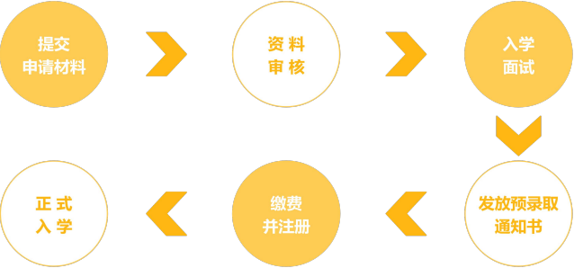

入 学 须 知 **/** Admission requirements

**申请流程／Application Process**

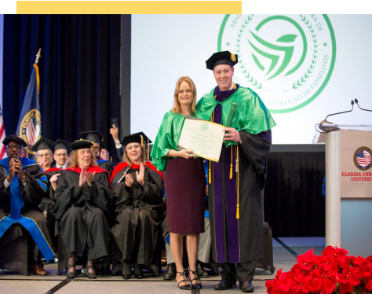

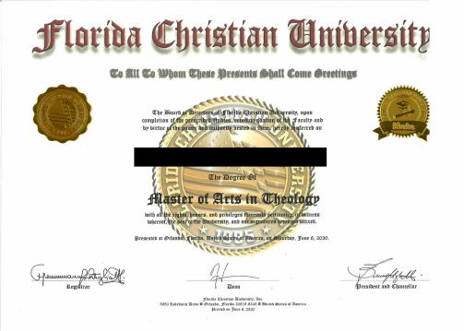

**学位 证书样本**

学 位 证 书 颁 发 **/ Issuance of Degree Certificate**

**学位证书颁发／Application Process**

学生必须修满FCU学位文凭要求的所有学分， 完成论文并通过答辩，可获得由FCU颁发 的商业管理理学硕士学位证书。毕业后学生可自主选择前往美国参加本校举行的毕业典礼， 体验国际化的学术氛围，感受被授予学位的庄严仪式。

Students must complete all the credits required for the FCU degree diploma, complete and

defend their thesis, and receive a Master of Science Degree in Business Administration issued

by FCU. After graduation, students can choose to go to the United States to participate in the

graduation ceremony held by the university, experience the international academic atmosphere,

and feel the solemn ceremony of being awarded a degree.





Thank You

