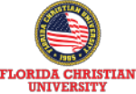

**佛罗里达克里斯汀大学**

佛罗⾥达克⾥斯汀⼤学（FCU)

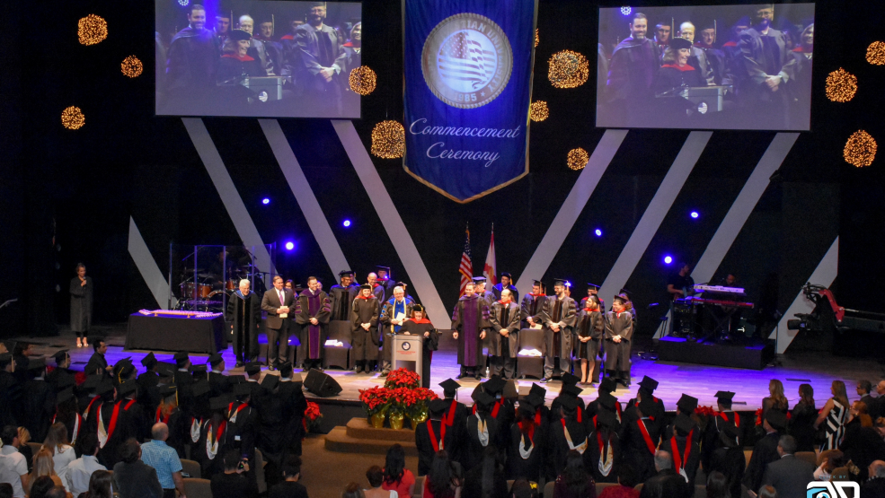Florida Christian University

**教育学硕 士 （ M . E . ）**



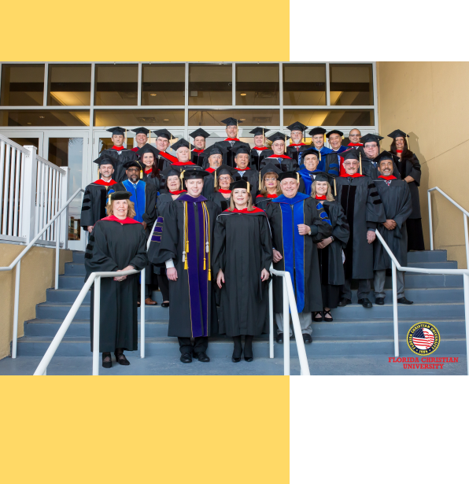

**History**

**学校简介 / University Profile**

佛罗里达克里斯汀大学（Florida Christian University ，简称FCU）创立 于1985年， 是位于佛罗里达州奥兰多市中心的一所综合性私立大学。地

理位置优越，紧邻奥兰多环球影城与奥兰多迪士尼主题乐园。

Florida Christian University (FCU), founded in 1985, is a comprehensive private university located in the heart of Orlando, Florida. It boasts a prime location in close proximity to the

renowned Universal Studios and Walt Disney World theme parks.







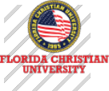

**History**

**学校简介 / University Profile**

佛罗里达克里斯汀大学（FCU）提供超过30种以上的大学与研究所专业，包

括商业、工程、传播、教育、艺术、人类学、社会科学、健康、护理等。

FCU长久以来在学科的教学与研究方面都有卓越的声誉，是符合ABHE以及

许多美国教育部认可的认证机构认可的大学。

Florida Christian University (FCU) offers over 30 diverse undergraduate and graduate programs, spanning various disciplines such as business, engineering,

communication, education, arts, anthropology, social sciences, health, and nursing. FCU has a longstanding reputation for excellence in teaching and

research across these fields and is accredited by ABHE (Association for Biblical Higher Education) and numerous other recognized accreditation agencies by

the U.S. Department of Education.

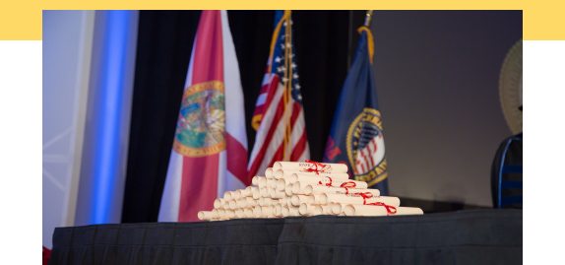

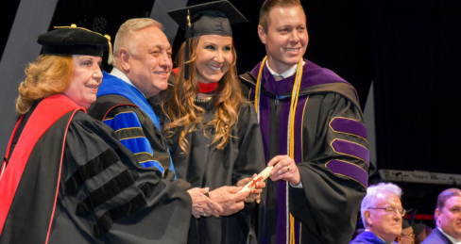

**使命/Mission**

通过实⽤、可变⾰性的⾼等教育，赋予学⽣国际性的视野和⽣存技能。

Empowering students with a practical, transformative higher

education that cultivates an international perspective and essential

life skills.

**愿景/Version**

培养⼀个全球变⾰推动者社区，这些变⾰推动者以基于卓越和正直

履⾏他们的使命。

Cultivating a global community of change agents, individuals who

uphold their missions based on excellence and integrity.

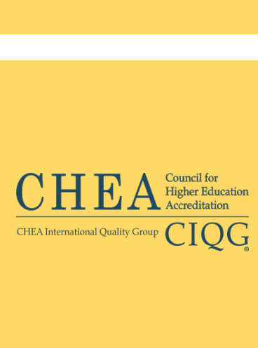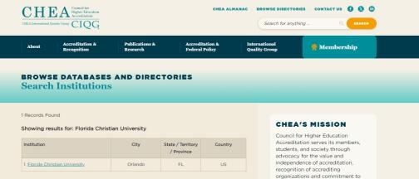

学 校 认 证 **/ LICENSURE**

高等教育认证委员会 （英语： Council for Higher Education Accreditation；简写： CHEA）是美国授予学院 和大学学位的组织 。成立目的是提倡通过认证而提供国家对学术品质自我监管，以证实高等教育认证机构 （包括地区、信仰、私人、职业和计划认证机构）的质量。该组织约有3000多个学术机构成员， 目前承认 大约60个认证机构。 高等教育认证委员会总部设在华盛顿特区，是高等教育品质保证国际网络的成员。

The Council for Higher Education Accreditation (CHEA) is a United States organization of degree-granting

colleges and universities. It identifies its purpose as providing national advocacy for academic quality

through accreditation in order to certify the quality of higher education accrediting organizations, including

regional, faith-based, private, career, and programmatic accrediting organizations.The organization has

accredited colleges and universities as members, and currently recognizes approximately 64 accrediting

organizations. CHEA is based in Washington, D.C. CHEA is a member of International Network for Quality

Assurance Agencies in Higher Education (INQAAHE).

CHEA查询官网： <https://www.chea.org/>

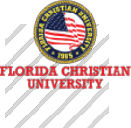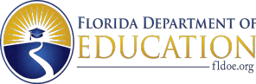

学 校 认 证 **/ LICENSURE**

独⽴教育委员会是佛罗⾥达州教育部的⼀个机构，对与⾮公⽴⾼等教育机构有关的事务负有法定责任。佛罗

⾥达克⾥斯汀⼤学获得佛罗⾥达州教育部独⽴教育委员会的许可，许可证号为 6361。

The Independent Education Commission is an entity within the Florida Department of Education responsible

<https://www.fldoe.org/>

for statutory oversight of matters pertaining to non-public higher education institutions. Florida Christian

University has obtained licensure from the Independent Education Commission of the Florida Department of

Education, with License Number 6361.

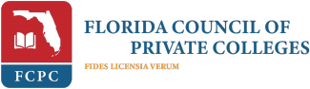

佛罗里达私立学院理事会 (FCPC) 的授予学位的高级会员



美国私立学院理事会 (CPCA) 的授予学位的高级会员

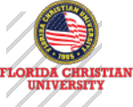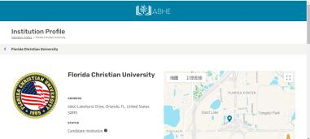

**Accreditation**

ABHE 认证委员会自 1947 年成立，是历史最悠久、经验更丰富的认证机构之一。自美国教育部 1952 年开始认可认证机构以来， ABHE 一直被 美国教育部认可为机构认证机构。

2024 年 2 月 13 日，佛罗里达克里斯汀大学获得圣经高等教育委员会认证协会的候选资格。候选资格是一种预认证资格，授予那些符合 ABHE 资格条件并具备可为五年内获得认证资格奠定基础的机构。候选院校得到美国教育部（ USDE）、高等教育认证委员会（ CHEA）、美国司法部 、美国退伍军人事务部以及美国其他相关联邦机构的认可。

ABHE Commission on Accreditation has been in existence since 1947, making it one of the older and more experienced accrediting bodies. ABHE has maintained recognition by the U.S. Department of Education as an institutional accrediting agency since the

Department began recognizing accrediting agencies in 1952

On February 13, 2024, Florida Christian University was approved for Candidate Status with the Association for Biblical Higher

Education Commission on Accreditation. Candidate status is a Pre-Accreditation status granted to those institutions that meet the ABHE Conditions of Eligibility and that possess such qualities as may provide a basis for achieving accreditation status within five years.Candidate institutions are recognized by the United States Department of Education (USDE), Council for Higher Education

Accreditation (CHEA), the US Department of Justice, the US Department of Veteran Affairs, and other relevant federal agencies in the United States.

ABHE查询官网： <https://www.abhe.org/>

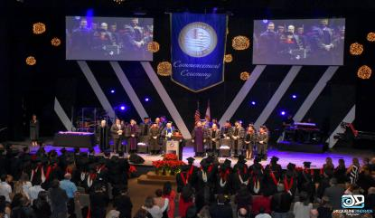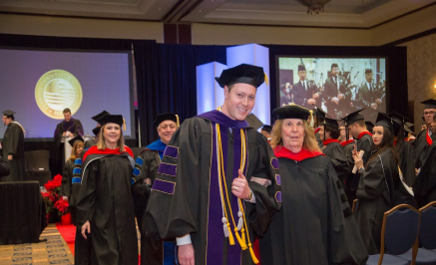项 目 介 绍 **/ Project Introduction**

教育学硕士 （**M.E.** ）

美国佛罗里达克里斯汀大学的教育学硕士项目独具特色，有效融合了教育理论与教育实践，强调在学术研究中注入人文关怀。课程设置涵盖了 教育学的各个领域，为学生构建了完整的知识体系。同时，项目注重实践能力的培养，通过实习和项目设计等活动，使学生能够将理论知识转化为 实际教学能力。此外，项目还致力于培养学生的国际化视野，让学生接触多元化的教育理念和教学方法。优秀的师资队伍为学生提供了高质量的教

学和指导， 确保了项目的学术水平和教育质量。

The Master of Education program at Christian University of Florida uniquely integrates educational theory with practical application, emphasizing the infusion of humanistic care in academic research. Its curriculum covers various fields of education, building a comprehensive knowledge system for students. Meanwhile, the program places a strong emphasis on cultivating practical skills through internships and project designs, enabling students to translate theoretical knowledge into

practical teaching abilities. Additionally, it strives to foster students'international perspective, exposing them to diverse educational concepts and methodologies. With an outstanding faculty providing high-quality teaching and guidance, the program ensures academic excellence and educational quality.

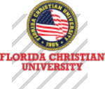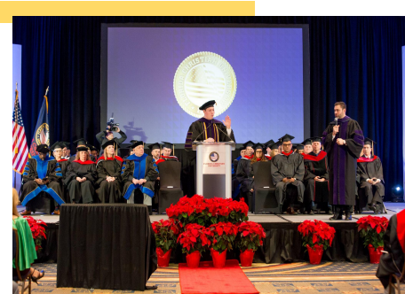

项 目 介 绍 **/ Project Introduction**

课程通过模拟实战、小组讨论和案例分析等方式，锻炼学生的思维能力和决策能力，使学生在 学习过程中不断积累经验，为未来的职业发展奠定坚实的基础。

美国佛罗里达克里斯汀大学的教育学硕士项目以其独特的培养理念、全面的课程设置、实践能 力的培养、国际化的教育视野和优秀的师资力量等特色， 吸引众多有志于深化教育理论、提升教学 技能的教育工作者前来求学。

The course exercises students' thinking and decision-making abilities through simulated actual combat, group discussions, and case analysis, allowing students to continuously accumulate

experience during the learning process and lay a solid foundation for future career development. The Master of Education program of Florida Christian University, with its unique training concept , comprehensive curriculum, practical ability training, international educational vision and

excellent teachers, has attracted many educators who are interested in deepening educational theories and improving teaching skills to come to study.



项 目 优 势 **/ Advantages of the project**

**卓越的教育整合能力**

Outstanding Educational Integration Proficiency

整合了批判性思维与创造性思维、综合领导⼒，致⼒于为学⽣提供全⾯的教育⽅法

Integrating critical thinking and creative thinking alongside comprehensive leadership, we are committed to delivering a holistic educational approach to students.

**卓越的教育经验** Exemplary educational experience

促进学生在国际市场的成长和培养领导力发展

Facilitating students' growth in the international market and fostering leadership development.

**完善的国际教育系统** A well-developed international education system

丰富学⽣经验并培养全球世界观， 500 多个国际⽂凭区域的学者和专业⼈⼠

Enriching student experiences and cultivating a global worldview through a network of scholars and professionals across over 500 international diploma regions.

项 目 优 势 **/ Advantages of the project**

**灵活多样的授课方式** Flexible and diverse teaching methods

我们提供各种形式的灵活学习方式，从100%线上授课到线下在校授课、或两者相结合 的灵活教学形式。

We offer a variety of flexible learning options, ranging from 100% online instruction to on- campus in-person classes, or a combination of both in a flexible teaching format.

**多种语言教学** Instruction in multiple languages.

我们为学生提供用语言学习的机会，可选择英语、中文、葡萄牙语和西班牙语的课程。 We provide students with opportunities for language learning, offering courses in

English, Chinese, Portuguese, and Spanish.

**学位证书认证** Degree certificate certification

学位证书可以获取海牙与WES等权威认证 ，确保学术信誉无忧

We provide students with opportunities for language learning, offering courses in English, Chinese, Portuguese, and Spanish.

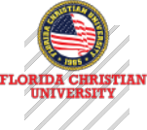

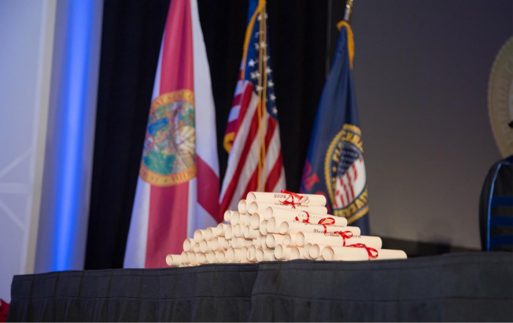

**WHAT MAKES US DIFFERENT**

课 程 设 置 **/ Curriculum**



**核心课程／ASSOCIATE**

|  |  |
| --- | --- |
| u 族群与多样性  Ethnic Groups and Diversity  u 绩效评估  Performance Evaluation  u 教育项目  Education Projects  u 原则教育中的课程理论与组织  Curriculum Theory and Organization in Principle-Based Education | u 课堂教师的指导咨询  Classroom Teacher Guidance and Counseling  u 应用于教育的神经科学  Neuroscience in Education  u 高等教育的组织与管理  Organization and Management of Higher Education |

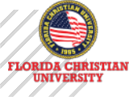



**核心课程／ASSOCIATE**

|  |  |
| --- | --- |
| u 优质教学  Quality Teaching  u 教育与评估  Education and Evaluation  u 多文化教育  Multicultural Education u 多元智能  Multiple Intelligences | u 科学研究：理论/项目  Scientific Research: Theory&Project  u 论文：研究 /写作  Thesis: Research&Writing  u 论文：答辩  Thesis: Defense |



入 学 须 知 **/ Admission requirements**

**入读条件／Admission conditions**

u 获得教育学或相关领域的本科学历；

u 具有本科同等学历学位，并有两年以上工作经验。

（*未具上述学历的申请人，请提供一份管理或相关的成就描述，并向项目办公室提交补充附加材料进行特殊申请。）

**入读材料／Admission conditions**

u 入读申请表

u 个人履历表

u 个人陈述(入学动机信)

u 身份证正反面扫描件、护照首页扫描件

u 本科毕业证或学位证扫描件

u 本科成绩单扫描件

u 2寸白底证件电子照片

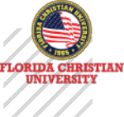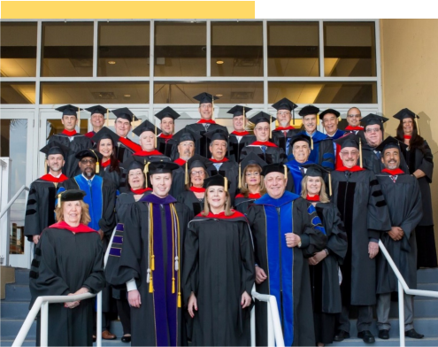

入 学 须 知 **/ Admission requirements**

**修读方式／Study Method**

u **类型：**线上美方课 +线下中方面授课

u **学制：** 15个月（具体以实际情况为准）

u **授课安排：**每个月的一个周末，每次两天

u **授课语言：** 中文、英文授课，配有现场翻译

u **教学方式：**教授讲授、案例分析、小组讨论、与行家研讨等，强调理论与

实践的互动



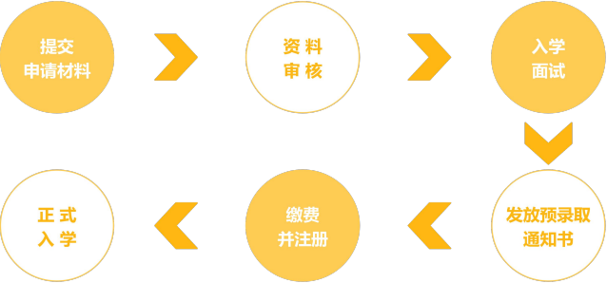

入 学 须 知 **/ Admission requirements**

**申请流程／Application Process**

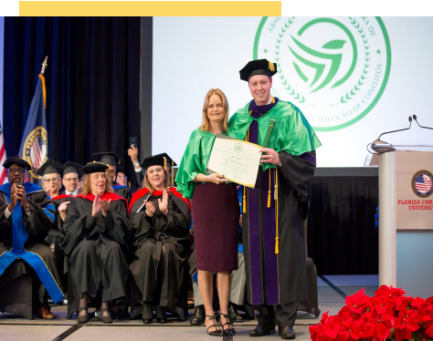

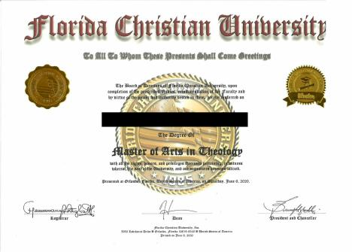

**学位 证书样本**

学 位 证 书 颁 发 **/ Issuance of Degree Certificate**

**学位证书颁发／Application Process**

学生必须修满FCU学位文凭要求的所有学分， 完成论文并通过答辩，可获得由FCU 颁发的教育学硕士学位证书。毕业后学生可自主选择前往美国参加本校举行的毕业典 礼，体验国际化的学术氛围，感受被授予学位的庄严仪式。

Students must complete all the credits required for the FCU degree diploma, complete the thesis and pass the defense to receive a Master's degree certificate in Education issued by

FCU. After graduation, students can choose to go to the United States to participate in the

graduation ceremony held by the university, experience the international academic

atmosphere, and feel the solemn ceremony of being awarded a degree.





Thank You

