直面未来机遇
实现健康产业成就
FACECHANCE IN THE FUTURE
ACHIEVE SUCCESS IN HEALTH INDUSTRY
成就医疗卫生领域具有专业能力，未来视野，全球化创新能力 的杰出管理者和创造者
HEALTH CARE INDUSTRY

ESG
BUSINESS SCHOOL

/ Intewing
医疗卫生管理硕士/博士

Management of Health Care Institutions
tel. 010-83030010
add,北京市海淀区北航致真大厦A座5层
tel. 010-85677661
add.北京市朝阳区国贸银泰中心C座32层
法国克莱蒙高等商学院
Groupe ESC Clermont
ESC Clennout Graduate School of Mauagemeut
Prepare Yourself Outstanding Leadership iu the Health Industry

行业需求
行业前沿
INDUSTRY FOREFRONT
ment.
随着科技创新的不断加速以及法律体系的不断完善，整个社会对医疗卫生硬性和软性的要求也在不断提 高，专业的医疗卫生机构需要越来越多的具有专业医疗卫生知识以及可以对医疗卫生资源进行合理管理与 调配的专业人才。
With the continuous acceleration of scientific and technological innovation and the continuous improvement of the legal system, the entire society has improved the requirements of medical and health care. Professional medical and health institutions need more and more industry expert with professional medical and health knowledge, management ability to make full use of relevant resources.
因此娴熟的管理技能，高效的绩效管理，以及良好的协调能力已成为该行业未来高管的必备条件。
Therefore, skilled management ability, efficient performance management, and good coordination skills is required to be the qualifications for the industry future leaders.
在“健康中国”国家大战略指引下，宏观层面发布利好产业政策、各级政府设立多层次大规模项目基金， 资本市场适应灵活机制快速相应，多方共同推动了中国医疗健康行业进入发展快车道。
Under the guidance of the Healthy China" national strategy, industrial policies have been issued in terms of the macro-level, governments at all levels have set up multilevel large-scale project funds, and the capital market adapts to flexible mechanisms so as to respond quickly, which have jointly pushed China's health industry to enter the fest track of development.
伴随着行业的蓬勃发展，医疗健康行业的高层次医疗卫生管理人才越来越紧缺及抢手。
对企业、医疗机构、学术机构、卫生行政部门而言，急需培养既懂得人性化医疗服务又懂得市场化运营管 理的医疗健康行业人才。
Along with the vigorous development of the industry, high-level health management talents in the health care industry are increasingly scarce and sought-after.
For enterprises, medical institutions, health administration department, there is an urgent need to cultivate talents fbr health care industry who understand both humanized medical services and market-oriented operation and manage
1 [ 1
I / /
1%
,u l -
■
h'
K\

Kev Figures of ESC Clermont
克莱蒙高等商学院

Groupe ESC Clermont

ESC Clermont Graduate School of Management
毕业生

Graduate
遍布全球130个国家

超200家
企业合作伙伴

Corporate partners
roupe ESC Clermont is a well-established French Business School. ESC Clermont is the short name of Ecole superieure de commerce de Clermont-Ferrand. It was found in 1919, under the patronage of the Ministry of Commerce, the City of Clermont-Ferrand, the Conseil General du Puy-de-Ddme (General Council), the Chamber of Commerce and several partner companies. Since then, more than 12,000 men and women from all walks of life have walked the grounds of the Trudaine campus.
在校生来自全球
国家

Countries
Group ESC Clermont是一所声誉卓著的法国商学院。ESC Clermont (法语全称：Ecole Supcrieure de commerce de Clennont-Ferrand),即克莱蒙高等商学院，简称“克莱蒙高商”。它成立于1919年，由法 国商务部、克莱蒙费朗市、唐塞尔总理事会、商会和一些伙伴公司的支持而成立。从那时起，来自各 行各业的12000多名男女学员从特鲁登校区学习毕业。
国际合作伙伴

Higher Education partners
的国际学生

Foreign students
商校认证

AACSB/AMBA/EPAS
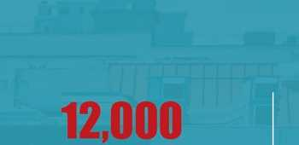

权威认可

Authorized Accredutation
权威联盟成员 Authorized Alliance Members
中国教育部认可 Recognized bv the Ministry of Education of China
法国克莱蒙高等商学院（ESC Clermont）系中国教育部认可的海外正规院校，
在教育部“教育涉外监管信息网”中被直接翻译为克莱蒙高等商学院。
［http://www.jsj.edu.cn/选择“国外院校”栏目中的“法国”，搜索ESCClennout］
另外，中法教育部于2020年1月13日签署的《中华人民共和国教育部与法国高等教育、科 研与创新部关于高等教育学位和文凭互认的行政协议》，再次明确保障了法国克莱蒙高等 商学院的文凭被中国教育部认可。
ESC Clermont是多个国际知名联盟和机构的成员，例如:
Group ESC Clermont 是 Grandes Ecoles 精英大学校（非营利性工程学校、管理 学校和提供其他专业的高等教育机构的 协会）的会员。
中华人民共和国教育部
AGERA (The Alliance des Grands Ecoles Rhone-Alpes Auvergne)的成员，AGERA是 法国最重要的商学院联盟之一。
EMBS联盟的创始成员之一，EMBS （欧 盟管理和商业科学网络）目前有16加欧洲 高等教育机构（大学和商学院）。Groupe ESC Clermont在1998年至2014年期间主持 该联盟的工作，自2014年9月起负责其法 律顾问和财务业务。

教育涉外监管信息网
sj.moe.gov.cn
2021年1月I】日星期—
預竺佰怠
法規文件
p 済信入关ta字
百页
即动恋
涉外办学
国外源
专豪访淡
Ecole sup^xieuie de coanexce de Cleiaont 'ESC 中文校名：克莱養高等商学険
障止：wnr.e8c-clwnont.fr
Groupe ESC Clermont是EFMD成员。
EFMD （欧洲管理发展基金会）是全球最 重要的商学院网络之一，作为该网络的一 部分，为师生交流、知识共享和合作带来 了许多机会。
Groupe ESC Clermont是NIBES网路的活跃成 员。NIBES （国际商学院和经济学院网络） 拥有20所商学院和经济学院，分布在5大 洲，其中包括2013年之前一直担任法律顾问 的 Groupe ESC Cleront ,自 1996年以来让 Avec5000名校友参与学生流动项目。
备注：
aacsb认证 Accredited byAACSB aacsb
Group ESC Clermont自成立以来一直是国家认可的学校，这证明了它作为一个可靠的高等教育机 构的合法性和稳固的声誉。自1985年以来，克莱蒙高等商学院一直是高等商学院会议（Conference des Grandes Ecoles） 的成员；
权威排名 Authorized Ranking
随着学校项目组合的发展，特别是与全球化商业世界不断变化的需求、创新和教学相适应的新课 程的推出，克莱蒙高等商学院提供了全面的课程。创立于2007年的国际管理学学士或管理学硕士 课程，在法国《费加罗报》［Le Figaro］排名和国际排名中都占据显著位置，而且经常上榜（英国 《金融时报》榜单中前100名）o
自1986年以来，一直是高等商学院管理学院（Chapitre des Grandes Ecoles de Management）的成 员；井于2005年获得AACSB认证，获得国际认可。ESC Clermont是拥有AACSB认证（国际高等 商学院协会）的为数不多的商学院之一（全球不到5%的学校获得此认证）。AACSB国际认证提供 对学校组织过程质量的独立评估，确保所提供课程的内容和质量符合既定的国际标准。
法国排名
2018年法国最好的商学院第22名——《法国费加罗报［LeFigare］》排行榜。
（该报纸创立于1826年，是法国第二大综合性日报） 最受研究生推崇的商学院第9名——《法国学生报U' Etudiant］》排行榜。
国际排名
2018年全球最佳管理硕士 100强——英国《金融时报》排行榜
AACSB -伝
accred<teo
^IfCLERMONT 弓牙 FERRAND
vs/ ccoles aqera
+
Clermont
auvergne
mOtropole
CAMPUS REGION® DU NUMtRIOUf
ucn
UNIVERSITt Clermont Auvergne
HH Erasmus+
J EFMD _
站-EPAS ©歸
ucn
universitC
Clermont Auvergne
Erasmus + | |
CAMPUS REGION*
DU NUMtRIOUI
CCI puy-de-dOme
La Region
Auvergne-Rhdne-Alpes
-^jrCLERMONT ♦■FERRAND
Clermont auvergne mOtropole
CCI PUY-DE-D0ME
La Region
AuvGfgne-Rhdne-Alpes
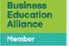
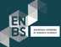
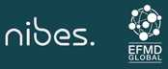

项目起源

hy this project

项目人群

Who should anend

随着中国医疗卫生事业体质改革的深入，医疗健康产业成为最具潜力的行业之一， 再迎来历史性发展机遇的同时，改革也给其内部机制与外部环境带来了全新挑战。 医疗健康机构间的竞争已经从单纯的医疗健康专业服务竞争，变成了综合实力和经 营理念的较
因此秉承法国医疗卫生领域的全球领先优势，以及商科院校在管理实战方面的教学 优势，法国克莱蒙高商的MHI医疗卫生管理硕士/博士项目应运而生。
ith the deepening of China "s health care system refonn, this industry has become one of the most potential ones. While facing historic development opportunities, the reform has also brought new challenges to its internal mechanism and external environment. The competition between health care related institutions has changed from the competition of health care professional services to a contest of comprehensive strength and business philosophy.
herefbre, adhering to France "s global leadership in the field of medical and health care, as well as the teaching advantages of business schools in the field of management, the Master/Doctor in Management of Health Care Institutions Program of ESC CLERMONT comes into Being.
此专业面向大多数主要针对从事健康、医疗、卫生领域工作并有意愿提升管理经验 的人员。
Mainly fbr those who are engaged in health, medical, sanitation industry and willing to improve their management skill.
包括但不限于以下机构工作人员或管理人员:
The staff or leaders of the following institutions, including but not limited to.
-医疗卫生行政机构
-Medical and Health Administrative Agencies
-公立医院、私立医院、诊所 -Public and Private Hospitals, Clinics
-疗养中心、康复中心、老年人康养机构、育儿和幼儿保育、 重返社会协会等
-Convalescent Center, Rehabilitation Center, Gerocomium, Maternity Matron, Early Childhood Care and Reintegration Commission
-家庭医疗帮助机构 -Family Medical Services

培养目标

ultivation Object

培养方向

Cultivation Direction

health care industry
MHI医疗卫生管理硕士/博士项目将有效结合医疗卫生行业专业性与管理领域系统性知识，为在不同 医疗健康机构从事经营、管理的学员提供行业及职业发展所必备的管理理论、管理工具及行业前沿 的传授，从而培育医疗卫生领域具有专业能力、未来视野、全球化创新能力的杰岀管理者和创造 者。
he MHI Master/Doctor Program will effectively combine the professional knowledge of the health care industry with the systematic knowledge of the management field. It will provide students who are operation and managing in different health care institutions with the management theory, management tools and industry frontiers necessary fbr industry and professional development. The ESC Clennont 一 MHI program
is committed to cultivate outstanding entrepreneurs and leaders with professional competence, future development view and global innovation ability in
ESC Clermont-MHI硕士/博士项目旨在培养既精通医疗行业的政策法规和技术专利，又熟谙企业 战ESC Clermont-MHI硕士/博士项目旨在培养既精通医疗行业的政策法规和技术专利，又熟谙企业战略运营、市场营销、人力资源、财务金融等，并拥有丰富实践经验的跨学科复合型紧缺人才，从而能够将自身及企业的资源整合，引领企业的创新发展，推动中国医疗健康行业全球化升级。
ESC Clermont - MHI Master/Doctor program aims to cultivate interdisciplinary and versatile talents who are proficient in the policies and regulations of the health industry and technology patents, and familiar with corporate strategic operations, marketing, human resources, accounting and finance as well as have rich practical experience. As a result, the talents can integrate the resources of oneself and the enterprise to lead the innovative development of the enterprise and to promote the upgrade of globalization of China's health industry.

部分师资
马克•莱考特是组织与管理教授，克 莱蒙ESC集团研究中心主任，Clenna研 究员，交互管理、人类潜能与创新的 核心成员。参与研究项目“极端情况 管理”及“开放实验室的探索创 新”。他的研究侧重于社会网络在领 导组织方面的作用以及文化组织的创 新管理实践。他最近在《极端情况管 理杂志》中发表了 “知识的扩展和社 会网络的动员”以及在《法国管理杂 志》中和帕斯卡合作发表“脆弱的合 作关系——格拉诺维特计划追溯”。
理查德•索帕诺是克莱蒙高等商学院学术主任兼企业战略教授。他也是Clerma成员。管理学博士、副教授， 他的研究和教学侧重于战略和组织变革、企业创新以及知识在管理中的作用和相关性。他在这些领域撰写多 篇科学文章和著作。他还曾在法国管理学院担任院系及研究中心领导。
Richard SOPARNOT is academic director and professor of corporate strategy at Clement College of business. He's also a member of clerma. His research and teaching focus on strategic and organizational change, enterprise innovation and the role and relevance of knowledge in management. He has written many scientific articles and works in these fields.He also served as a department and research center leader at the French School of management.
Marc Lecoutre is Professor of organization and management, director of research center of Clement ESC group, researcher of derma, and a core member of interaction management, human potential and innovation. Participate in the research project "extreme situation management" and "exploration and innovation of open laboratory". His research focuses on the role of social networks in leading organizations and the innovative management practices of cultural organizations. He recently published "knowledge expansion and social network mobilization" in the Journal of extreme situation management, and in the French Journal of management, he collaborated with Pascal to publish "fragile partnership: tracing the granovit project".
凯瑟琳教授是克莱蒙高等商学院创新与发展部战略学教 授，主要教授战略管理和卫生经济学。擅长：卫生系统法 规、医院管理、卫生政策。
DOS SANTOS Catherine is a professor of strategy in the Department of innovation and development. Clement College of business, focusing on strategic management and health economics. Good at: health system regulations, hospital management, health policy.
ESC Clermont - MHI program aims to cultivate interdisciplinary and versatile talents who are proficient in the policies and regulations of the health industry and technology patents, and familiar with corporate strategic operations, marketing, human resources, accounting and finance as well as have rich practical experience. As a result, the talents can integrate the resources of oneself and the enterprise to lead the innovative development of the enterprise and to promote the upgrade of globalization of China °s health industry.
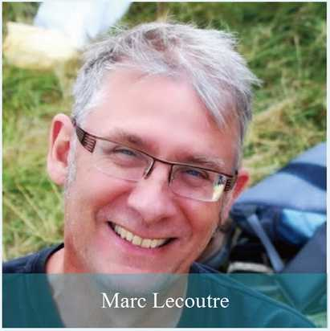
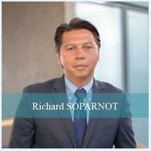
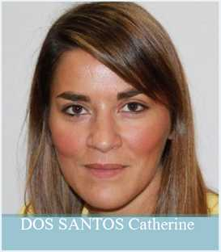

Professor team

部分师资

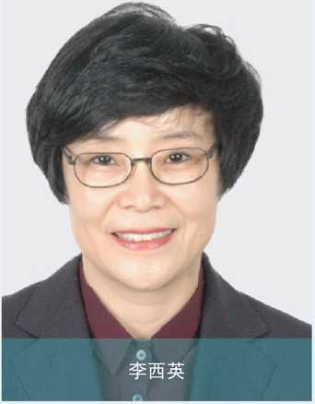
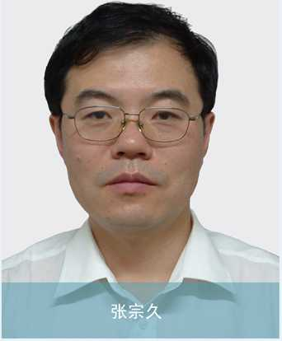
国家《医疗服务与质量安全报告》编写专家
国家卫健委医政医管局《18项核心制度要点》编写专家 医院评审标准编写及评价国家级核心专家
国家卫健委医院管理研究所特聘专家
国家医疗质量年度评价专家
国家医疗管理中心专家
Expert in compiling National Report on Medical Service and Quality and Safety Expert in compiling "18 Key Points of Core System" of Medical
National Core Expert in Compilation and Evaluation of Hospital Evaluation Standards Special expert of Hospital Management Institute of National Health Commission National annual evaluation expert of medical quality
Experts of national medical management center 现任清华大学医院管理研究院常务副院长。曾任卫生 部医疗服务监管司司长、卫生和计划生育委员会卫生 应急办公室(突发公共卫生事件应急指挥中心)主任。 曾任国家卫生健康委员会医政医管局局长。
Now as the executive vice president of the Hospital Management Research Institute of Tsinglma University. Once as the director of the Department of medical service supervision of the Ministry of health and director of the health emergency office of the health and Family Planning Commission (public health emergency command center).
Once as the director of the medical administration bureau of the National Health Coiuicil.

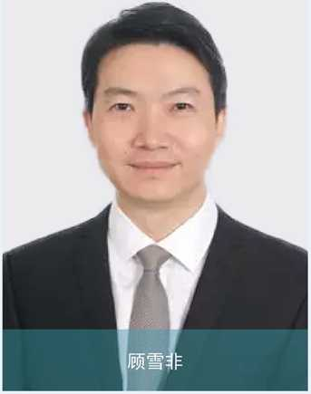
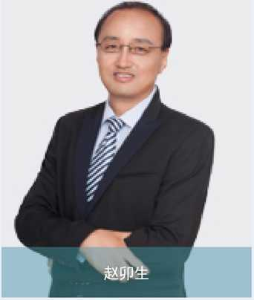
国家卫生计生委卫生发展研究中心副研究员，医疗保障 研究室副主任，硕士研究生导师。
中国医疗保健国际交流促进会健康保障分会副会长 中国卫生经济学会医疗保险专业委员会常务委员 中国医疗保险研究会理事
中国健康促进与教育协会移动健康分会常务委员
中民社会救助研究院智库专家
Associate researcher of national health and Family Planning Commission health development research center, deputy director of medical security research office. Supervisor of Graduate Student
Vice president of health insurance branch of China Association for international exchange of medical care
Standing committee member of medical insurance professional committee of Chinese society of health economics
Director of China Medical Insurance Research Association
Standing Committee member of Mobile Health Branch of China Health Promotion and Education Association
Think tank expert of China Civil Society Relief Research Institute
国家卫健委人才中心、国家中医药管理局讲座教授
中国生命关怀协会医院综合发展专业委员会常务委员、法务部主任
中国医院协会疾病与健康管理专业委员会委员、法务部主任
中国生命关怀协会医院人文建设专业委员会常务委员
清华大学、北京大学、中国人民大学、中南大学等知名高校讲座教授 北京警察学院客座教授，延安干部培训学院特聘教授
四渡赤水干部学院特聘教授
Professor of National Health and Health Commission Talent Center and state administration of traditional Chinese medicine
Standing Committee member of Hospital Comprehensive Development Professional Committee of China Life Care Association, and Director of the Legal Department
Member of Disease and Health Management Committee of China Hospital Association, and Director of the Legal Department
Standing member of hospital liumanistic Constniction Committee of China Life Care Association Professor of well-known universities such as Tsinghua University, Peking University, Reum in University of China and Central South University
Visiting Professor of beijing police college, distinguished professor of Yan 'an Cadre Training College
Distinguished Professor of Training Academy of Si Du Chishu
汇聚国内外著名教授，他们兼具丰富的实践经验，深厚的理论基础，高超的文化素养，授课师资平均至少有15年以上教学及企业管理相关实操经验，并结合中国国情，以全球化视角为学员提供理论与实践之间科 学转换的极致体验。

urriculum System 课程体系

学术委员会cademic System
学习全程中，项目学术委员会将根据学员的研究课题，安排对应的中法导师及学术团队，开展 论文工作坊对学员的论文写作进行跟踪指导，确保学员学习过程中的学术思维提升及能够顺利 完成论文及答辩。
During the study, the academic committee of ESC Clermont program will arrange the corresponding Chinese and French supervisors and related team to hold thesis workshops fbr instructing the thesis writing according to students ° research topics so as to ensure that the can improve their academic thinking and successfully complete the thesis and defense.
攻读MHI硕士/博士项目分为两个阶段，完成必修课程和论文撰写并答辩。学员在学习过程中进行论文准备，即确 定论文研究方向和主题；完成论文写作及答辩，方可顺利毕业并获得硕士/博士学位。
The MHI Degree Program is divided into two phases:
Phase 1: compulsory courses and elective courses
Phase 2: thesis writing and oral defense.
During the study process, participants prepare thesis writing to determine research direction and topic; participants finish the thesis writing and attend the oral defense, they can successfully graduate and obtain a master/doctoral degree
学习周期
rogram Duration
硕 士: 1-1.5 年
Master : one year- one plus half a year
博士 ：3年
Docter : three years
管理基础（包含：组织行为与领导力创新、创造力和创业精神，战略管理等）

学位授予egreeAward
学员完成所有课程，经考核合格，且通过硕士/博士论文答辩，在得到克莱蒙高等商学院学位评审委员 会的认可后，学员将获得由克莱蒙高商颁发的硕士/博士学位证书，学位全球认可。
After completing all the courses, passing the examination and master/doctor thesis defense as well as being approved by Degree Review Committee ofESC Clermont, students will receive the diploma which is globally recognized.
课程安排
Course Arrangement
卫生经济学和社会经济学卫生领域的 法律和监管卫生健康管理控制健康 和社会风险管理质量和认证程序危机 管理等
卫生经济学和社会经济学卫生及社会机构 的人力和战略资源管理卫生和社会机构管 理医疗风险管理与质量医药企业市场营销
专业经验（写作和应用研究论文答辩）包含：研究论文方法论，论文及答辩。

毕业典礼 raduation Geremony
毕业学员将受邀参加克莱蒙高等商学院隆重举办的毕业典礼，这将是学习阶段的完美句点，同时，相聚重 逢也为校友间未来交流建立新的纽带。
The graduate will be invited to the grand graduation ceremony of ESC Clermont, which will be a perfect end to their students, at the same time, reunion also builds a new bond fbr future exchanges among alumni.
授课语言 中文，英文或法文授课（现场配备专业中文翻译）
Teaching Language
授课时间 Teaching Time
授课形式 Teaching Format
Chinese, English or French (on-site professional Chinese interpreter will be equipped)
周末兼修制，每月集中授课1-2次，每次2天
Intensive classes will be taught on weekends, 1-2 times per month
核心课程通过线上及线下形式进行，学习期间将有机会参加行业研讨会， 名家讲座，法国母校之旅及国际研讨会。
Core courses are conducted online and offline. During the study, students will have opportunities to attend industry seminarsjectures delivered by famous scholars, study tour to French alma mater and international seminars.
*具体课程安排以学期开始前校方课程设置为准

AmiCATION^ GUIDANCE^
申请指南

申请条件
申请者具备医疗、卫生、健康等行业相关工 作经验，良好的沟通能力和学习能力
- MHI硕士：专科及以上学历三年以上相关 工作经验
- MHI博士：本科及以上学历 五年以上相 关工作经验
备注：条件优异者可适当放宽申请条件，但需提交附加材料。

申请材料
•报名申请表（中英文各1份）
•护照和身份证复印件1份
•最高学历证书复印件及公证件各1份 （需提供原件复核）
• 2寸蓝底照片4-6张（电子版即可）
•商务名片2-4张

申请流程
提交申请材料
通过
未通过
资格审查、面试
缴费
硕士 /博士
返还报名费
Application Materials
Applicants is required to have medical, sanitation, health and other relevant industry working experience, and also have good communication and learning ability.
- Bachelor degree, more than 3 years related working experience;
- Bachelor degree can directly attend the program
Note: If the applicant is superior, the application requirements may be relaxed appropriately, but additional materials are required.
Additional Materials
•Application forms (Chinese and English version)
•One copy of passport and ID card
•One copy of the highest academic/degree certificate and one notarial version (original documents is required fbr the review)
•4-6 copies of 2-inch photos with blue background (electronic edition is fine)
•2-4 business cards
Application Processes
Submit application materials
adopt
Qualification examination&interview
pay
to be a master/doctor
Reftuid of registration fee
